Dessa Shapiro

4th period

1/30/20

The Moon

In class, we are reading the book *A Long Way Gone* by Ishmael Beach about a boy who was forced to leave his home and struggles to survive. I think that the writer uses clear metaphors and expressions to explain complex situations and emotions.

In this book, you are introduced to the protagonist Ishmael beach and you learn he is an 11-year-old boy who lives in a small village in Sierra Leone, Africa. He lives with his father, mother, grandparents, and older brother, Junior. He lives a peaceful life and likes to listen to music and dance with his friends

“She said that people complain when there is too much sun and it gets unbearably hot, and also when it rains too much or when it is cold, But, she said, no one grumbles when the moon shines. Everyone becomes happy and appreciates the moon in their special way. (pg 16)” I think that this passage represents how even in times of war where people are suffering he had to be grateful that he was with his family and in a protected place. I also think that his grandma is using the moon as a metaphor as protection of the representation of the feeling of family. I think this passage foreshadows the rest of the story by saying that “ even if things are bad or feel hopeless the moon will always be there watching you.”

Ishmael continues to live in peace until their town was attacked by rebels and he was separated from his parents. He is with his brother and a group of friends that travel from town to town trying to find a safe place and their families. They are continuing to search for their families when they get attacks and Ishmael gets separated from his brother and friends. He spends a few days walking alone until he finds a group of boys that used to go to school with him and decides to join their group. Their new group continues to travel and almost see their families before they were killed by rebels. The boys are being shot at and Ishmael feels that there is no hope left.” We kept running until the sky swallowed the sun and gave birth to the moon. The bullets continued to fly behind us, but now their redness could be seen as they pierced through the bushes. The moon disappeared and took the stars with it, making the sky weep. Its tears saved us from the red bullets. (pg. 97-98.) I think that this passage is another example of a metaphor the author is using to make the story more interesting and clear. This metaphor also connects with the moon but I think this is saying that “the moon” that represented his family and home, is gone but it's still protecting him.

I think this is important to think about outside of this book and integrated into society. In our society today a lot of people feel like they don’t belong or something isn't right about them, and throughout the world, there are a lot of people physically and mentally suffering. And this can make them feel alone, but even if we don't notice it or even believe it there's always someone taking care of this. I also think kindness and empathy are a big part of this concept because if humans show empathy to others we will be able to better understand how other's lives are different than ours and how we can help them with their problems. We can apply this metaphor for life in life by thinking about the people who understand you and knowing that even if it doesn't feel like it there is someone protecting you.

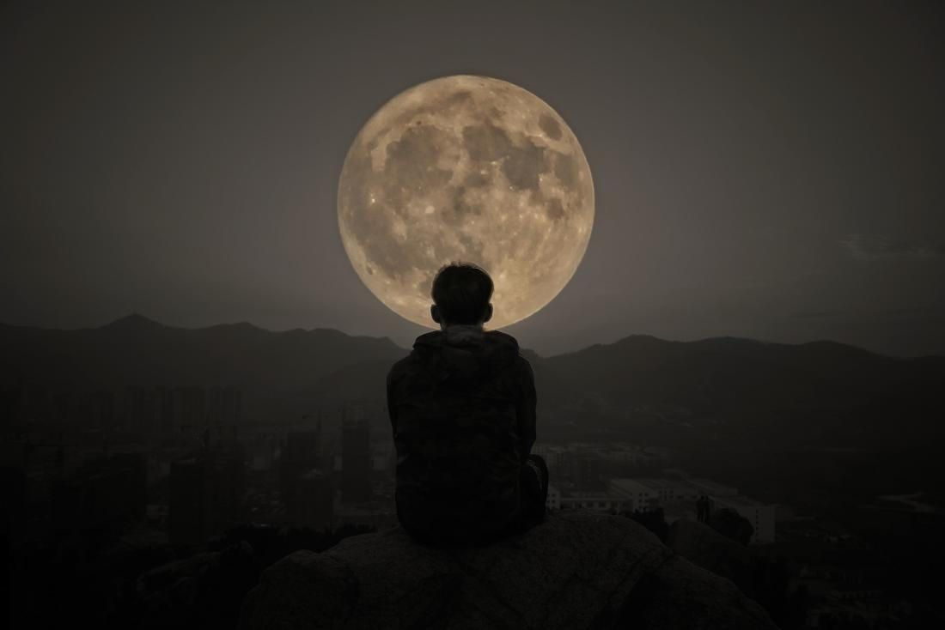

The Moon changes and sometimes you can’t see it but it’s always there